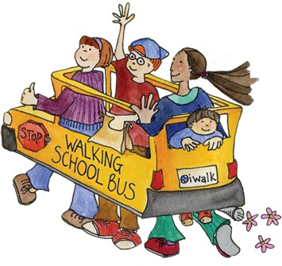

Walking School Bus!!!!
Let’s walk to school!!! On Wednesday, October 7th, we will be walking to school on the Walking School Bus!!! To promote a more physically active lifestyle, Ivy Hill will be participating in a walk-to-school program where six starting points throughout our neighborhood will be established for all students to meet with teachers and parents to walk to school! The six starting points will be:
- Douglas and Hintz-8:30 start to Ivy Hill
- Camelot Park- 8:40 start to Ivy Hill
- Windsor and Valley- 8:45 start to Ivy Hill
- Pinetree and Valley- 8:45 start to Ivy Hill
- Ivy and Arlington Heights Road- 8:40 start to Ivy Hill
- Burke and Palatine Road 8:40 start to Ivy Hill

All students are welcome to participate. If you live on the other side of a busy road (Arlington Heights Road, Palatine Road, etc.) you can drop your child(ren) at the starting point closest to your home. Also, you can meet up with the Walking School Bus as it passes your house- you don’t have to start at the starting points. Let’s get active!!!

** At this time, all bused students will still be picked up and dropped off at Ivy in the regular location. These students will be provided with walking opportunities throughout the school day.

