Arlington Heights
Police Department
200 E. Sigwalt Street
Arlington Heights, IL 60005

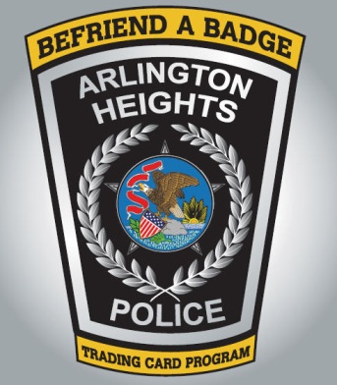

Befriend a Badge Trading Card Program

Contestant Information
Name: |  |  |  | Date:
 | Last | First | M.I.

Parent’s Name:
 | Last | First | M.I.

Address:
 | Street Address | Apartment/Unit #

 | City | State | ZIP Code

Phone: |  | Email:

OFFICIAL USE ONLY

Did you collect all 11 officer trading cards? | YES | NO | If yes, AHPD officer sign here

Are ALL 11 cards autographed? | YES | NO | If yes, AHPD officer sign here

Disclaimer and Signature
This form must be signed and collection of trading cards must be verified by an employee of the Arlington Heights Police Department.
Participation in this program does not guarantee the winning of any prizes. Winners will be notified via telephone call or email and provided further instructions.
Signature: |  | Date:

